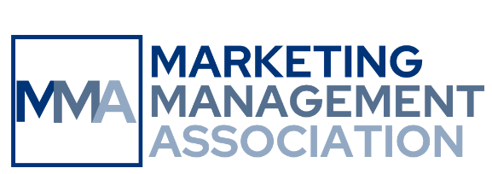
2027 Annual Master Teacher Award Competition
Call for Submissions

MMA Fall Educators Conference
September 15-17, 2027, Drury Plaza Hotel San Antonio Riverwalk, San Antonio, Texas

We encourage applications from outstanding marketing educators with a minimum of ten years of full-time experience in higher education teaching. Judging criteria include the quality of teaching philosophy and curriculum development; the significance of scholarly work related to teaching and learning; convincing evidence of teaching innovation, honors, and excellence; and scholarly contribution to marketing education.

How the Competition Works:
Submit your entry by the deadline. A panel of reviewers selects three finalists, each of whom will make a 15-minute presentation at the conference. The judges select the MMA Master Teacher Award winner based on these presentations.

What You Can Win:
The competition winner receives the 2027 MMA Master Teacher Award and $1,000. The other two finalists each receive MMA Master Teacher Excellence Awards and $250. Other noteworthy entrants may receive MMA Meritorious Master Teacher Awards. MMA recognizes all award winners at the conference awards lunch on Thursday, September 16, 2027.

How to Submit:
Use the CMT submission link on the conference webpage. The submission deadline is May 31, 2027. Submitting indicates your commitment to register for the conference by August 31, 2027, and attend if selected as a finalist or award winner.

What to Submit:
- Letter of application (250 words max), noting:
- teaching philosophy.
- Condensed curriculum vitae (500 words max), listing:
- places and dates served as a marketing educator.
- curriculum contribution, including marketing courses developed and/or taught.
- scholarship related to teaching and learning, and teaching-related honors.
- Summary of successful teaching (1,250 words max), noting:
- supporting evidence of using innovative approaches to teaching and learning.
- supporting evidence of teaching excellence (e.g., student evaluations, feedback from colleagues, impact on student success, impact beyond one’s own institution).
- supporting evidence of making a valuable scholarly contribution to marketing education.

The three sections of the application must be combined into a single Word file.

Questions? Contact the Competition Coordinator, Jean Beaupre, at jean.beaupre@nichols.edu.

